Project Plan

A simple data analysis tool – NSW Traffic Penalty

Jack Mcleod – s5135484

Lachlan White – s5182678

Meesum Khazmi – s5176618

Group 100

Table of Contents

1.0 Introduction 3

1.1 Problem Background 3

1.2 Scope 3

1.3 Document contents 3

2.0 Work Breakdown Structure 4

3.0 Activity Definition & Estimation 5

4.0 Gantt Chart 6

# Introduction

## Background

The purpose of this project plan is to develop a tool that enables users to perform a variety of data analysis tasks to a given data set, this scenario being for the ‘NSW Traffic Penalty’. The chosen dataset contains a range of information sets relating to traffic offences including offence descriptions, legislation, and incident dates. The given data sets cannot currently be efficiently analysed by any current software application NSW Traffic possess, giving the need for the new tool’s development. To enhance client interaction, the tool will feature a graphical user interface (GUI) supporting all functional aspects as well as usability for the end user. Following the completion of the proposed tool, NSW Traffic will be able to efficiently analyse large data sets which can aid in identifying traffic offence trends and statistics to help improve road safety across the state.

## Scope

The general scope of this project includes the fully functioning data analysis tool for NSW Traffic and working graphical user interface along with the support software development plan and project plan. The developed tool will feature no additional functionality as outlined in the software development plan. To ensure the success of the software development project, the outlined supporting documentation will be provided.

The data analysis tool will require the GUI along with six core functions (five required per specification, along with one ‘insight’ tool left the discretion of the developers). The GUI main function is to provide usability to the client, with the core functions performing a range of data analysis operations. The required features as per NSW Traffics instructions include:

* Report all information for penalty cases, for a user-selected period.
* Produces a chart to show the distribution of cases in each offence code, for a user-selected period.
* Retrieves all cases captured by radar or camera based on offence description, for a user-selected period
* Analyses the cases caused by mobile phone usage – including but not limited to trends over time and offence codes.
* Analyse the number of cases determined by specific parameters listed in the analysis tool including camera type, location ect.

## Document contents

This document outlines the entire design and implementation process with each stage that the project team will undertake throughout the various iterations for the data analysis tool. Included in this is *Figure 2.1, Figure 3.1 and Figure 4.1* which outlinesthe work breakdown structure, activity definitions and time estimates along with the Gantt chart for the entirety of the project respectively. The work breakdown structure diagram visually displays the required tasks for project completion from start to finish in chronological order. Similarly, the activity definition table describes in detail each element featured in the work breakdown structure along with estimated times for completion. Finally, the Gannt chart provides estimated time deadlines for a project prior to commencement, which can be adjusted throughout the project to predict weather the deadline will be met on time or not.

# Work Breakdown Structure

Depicted below in *Figure 2.1,* is the Work Breakdown Structure (WBS) for the required tasks to ensure project completion. The tasks have been modelled in a hierarchal structure; tasks scheduled at the top of each section needing to be completed before moving onto the next. The hierarchy of tasks also moves from left to right, for example the project planning must be completed before the application can be designed for this project.

***Figure 2.1 – Work Breakdown Structure for the data analysis tool project***

# Activity Definition & Estimation

Depicted below in *Figure 3.1*, is the further description of tasks featured in the work breakdown structure. The table features the task ID, task definition and the estimated time intervals required to complete each task.

|  |  |  |
| --- | --- | --- |
| **Task ID** | **Task definition** | **Estimated Time** |
| **1.0 Project planning** | | **8 Days** |
| 1.1 | Initial discussion with group members to select data set, delegate workloads and discuss the score of the project. | 1 day |
| 1.2 | Develop the initial project plan and its relevant documentation. This should include all the subsequent sections such as the problem background, project scope, potential business benefits and system capabilities | 2 days |
| 1.3 | Develop the Work Breakdown Structure for the planned project. This will enable all team members to visualise the required iterations for the project to be completed successfully. | 2 days |
| 1.4 | Develop the activity definitions of estimated time reports based on the definitions of the work breakdown structure. Each activity definition and its estimated time must be accurately documented to avoid confusion. | 2 days |
| 1.5 | Generate the projects Gantt charted based on the tasks defined in the work breakdown structure. The Gantt chart allows all project staff to visualise the schedule for the project’s duration providing accurate completion times | 1 day |
| **2.0 Problem Analysis** | | **9 days** |
| 2.1 | Group members to meet and discuss the system capabilities and propose the general idea off the application per the required specifications. | 1 day |
| 2.2 | Develop the user requirements as per the given specification document. This will outline how the user interacts with the final application. | 2 days |
| 2.3 | Develop the software requirements as needed for the data analysis tool. The outlined requirements can be found in the specification document provided by NSW Traffic. | 2 days |
| 2.4 | Model the uses cases and user activities in software design document. The final use case diagram should be completed to display how users will interact with the application. | 2 days |
| 2.5 | Final problem analysis meeting with group members to finalise any further documentation. | 2 days |
| **3.0 Application Design** | | **11 days** |
| 3.1 | Meet with group members to review the data and data structure, discuss any functional requirements, review any draft user interface design’s | 1 day |
| 3.2 | Develop and finalise software design chart. This will provide users info on how the software will operate. It should feature brief instructions on how to use all the functionality off the application. | 2 days |
| 3.3 | Design all the functionalities outlined in the software design document for the analysis tool. For each function, all the relevant support documents should be provided. The value of the function should also be mentioned. | 2 days |
| 3.4 | Determine each data structure pre function in the tool. The selection and benefits of each structure and its function should be documented. A brief description of the structure, list of data members should also be documented | 2 days |
| 3.5 | Brief designs of pseudocode will be presented to the group for each function and its data structure. This will provide a logical idea of how each function will work in the data analysis tool, establishing a solid foundation to build the final product. | 2 days |
| 3.6 | Design the visual layout of the tool, this should include any relevant graphics, icons and images. This will establish a strong foundation to build the final product. | 2 days |
| **4.0 Application build** | | **12 days** |
| 4.1 | Coding for tool – Writing all code to successfully open and access the data file and its contents. All GUI components should be working correctly. | 1 day |
| 4.2 | Coding for tool – Writing all code to successfully complete function requirement 1. This will allow users to report information on all penalty cases between a selected data range. | 2 days |
| 4.3 | Coding for tool – Writing all code to successfully complete function requirement 2. This will allow users to produce a chart which shows the distribution of cased in each offence code within a selected time range | 2 days |
| 4.4 | Coding for tool – Writing all code to successfully complete function requirement 3. This will allow users to retrieve all cases captured by radar or camera based on offence description within a selected time range. | 2 days |
| 4.5 | Coding for tool – Writing all code to successfully complete function requirement 4. This will allow users to analyse cases caused by mobile phone usage using specific parameters. Including trends over time, offence code and so on. | 2 days |
| 4.6 | Coding for tool – Writing all code to successfully complete function requirement 5. This will allow users to analyse the total number of cases within specific parameters. These parameters will include camera type, location and other fields. | 2 days |
| 4.7 | Coding – Finalise any further code needed to run the application successfully. This includes the data functionality and GUI | 1 day |
| **5.0 Application testing** | | **7 days** |
| 5.1 | Development stage of testing – This will be documented via a software testing plan. This will outline the entirety of the testing phase and what its objectives / aims are. | 1 day |
| 5.2 | Function testing – Test each functionality to ensure correct outputs of results. Each function must be able to handle all user input and successfully output any error fields if encountered. | 2 days |
| 5.3 | User acceptance testing – Final testing off the data analysis tool as a whole. The tool should work correctly and efficiently with the GUI. | 2 days |
| 5.4 | Documentation of results – A summary of testing results should be documented to ensure correct project principles are upheld in the unlikely event of the application crashing. | 2 days |
| **6.0 Final closing** | | **2 days** |
| 6.1 | Group members will meet one final time to ensure all requirements are successfully met. The group should also discuss and delegate workload for the tool’s user manual. This will document and describe how each function works | 1 day |
| 6.2 | Upon the completion of the user manual, the group will finally meet to discuss any last issues with the application if they arise. An executive summary document will also be finalised to reiterate the summary of the projects entirety. | 1 day |

# Gantt Chart

Depicted below in *Figure 4.1* is the project Gannt chart for the NSW traffic penalties data analysis tool. The Gannt chart features the entire projected timeline for actives required to complete the project, allowing project managers to provide time estimates to stakeholders. It also allowed project workers to have a in-depth understanding of the timelines for each aspect

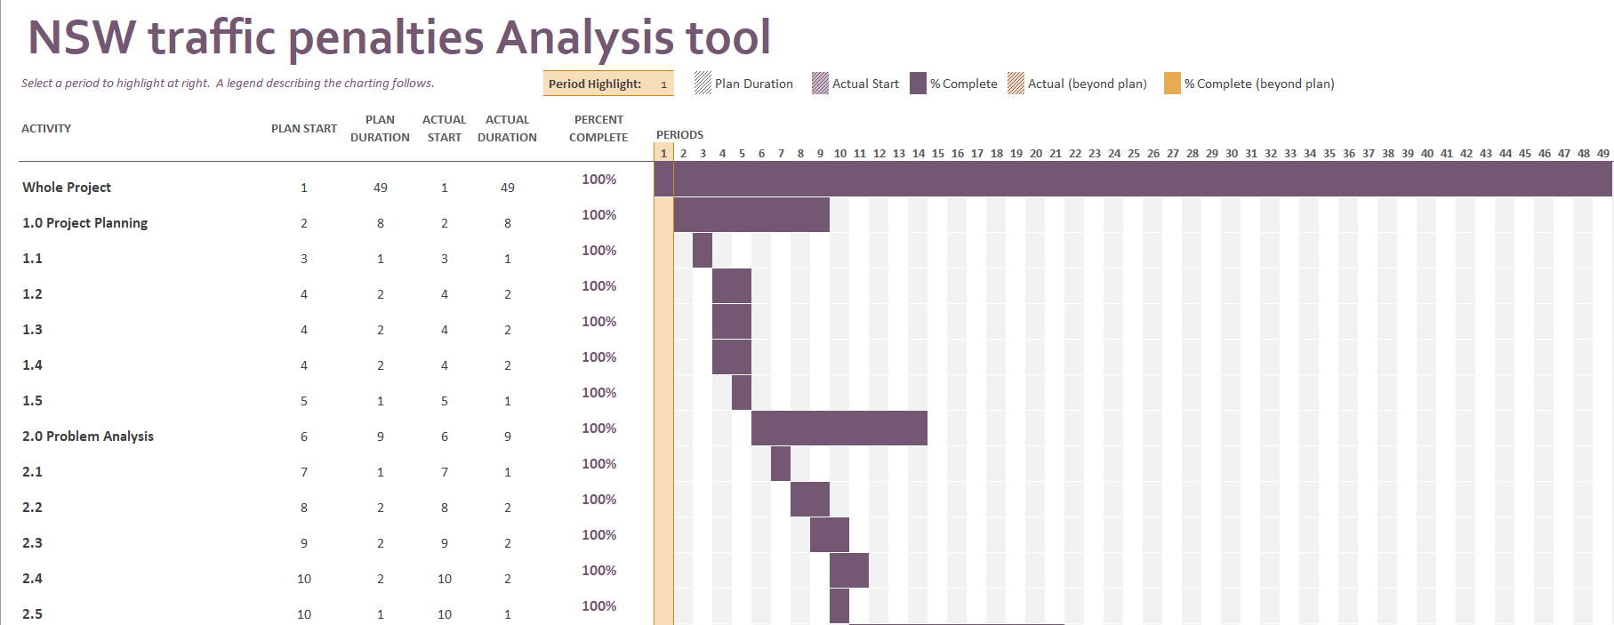

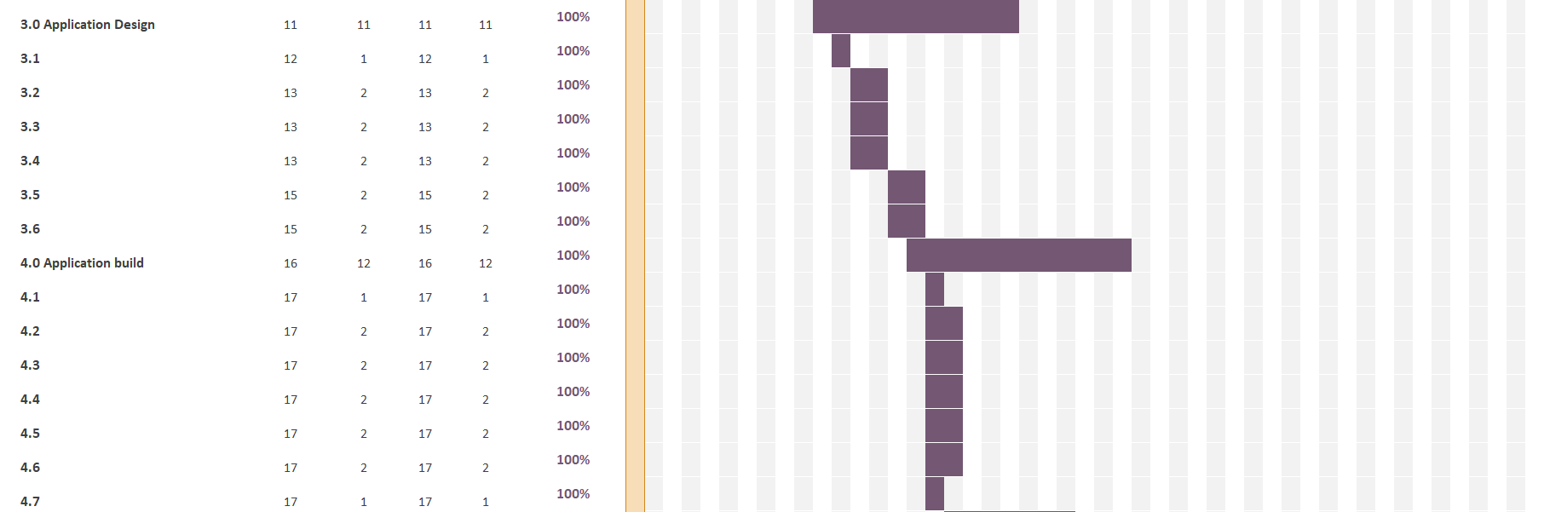

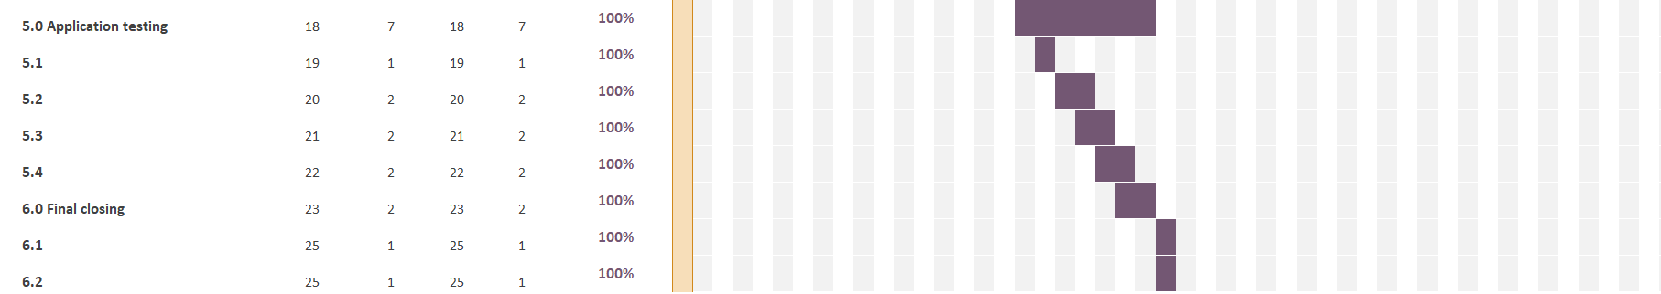

***Figure 4.1 – Project Gantt chart***